**Air Quality Analysis Report**

**Summary of Findings:**

This report summarizes the findings of an air quality data analysis conducted using the cleaned dataset and a Power BI dashboard. The primary goal was to assess air quality across various cities, identify significant trends, and provide actionable recommendations for improvement.

**Key Findings:**

**Pollutant Distribution**:

The top three most polluted cities based on AQI are Ahmedabad, Delhi, and Patna, with AQI values of 429, 259, and 235, respectively.

The least polluted cities include Coimbatore, Shillong, and Aizawl, with AQI values of 73, 52, and 35, respectively.

**Geographic Trends:**

Cities like Delhi and Mumbai displayed consistently high AQI levels, indicating severe pollution.

Coastal cities generally showed better air quality compared to landlocked regions.

**Temporal Patterns:**

declining AQI trend was observed from 2015 to 2020, with the annual average AQI dropping from 192 in 2015 to 113 in 2020.

Seasonal spikes in pollutant levels were prominent during winter months, attributed to lower dispersion rates and increased heating activities.

**City Comparisons:**

High AQI values in urban centers like Ahmedabad and Delhi suggest significant contributions from vehicular emissions and industrial activities.

Cities like Aizawl and Shillong displayed consistently lower pollutant levels, indicating effective environmental management and lower industrial density.

**Anomalies and Errors:**

Data inconsistencies, such as a placeholder row labeled "Total" and mismatches in city names, were cleaned before analysis.

**Correlations:**

A strong correlation exists between CO, NO, and PM2.5 levels, highlighting the combined impact of industrial and vehicular emissions.

**Recommendations:**

1. **Policy Implementation:**

Strengthen emission regulations, especially in industrial zones and high-traffic urban areas.

Vehicular Emissions: Implement stricter emissions standards and encourage the use of electric vehicles.

Industrial Regulations: Introduce better control mechanisms for industries contributing to SO2 and NOx emissions.

Urban Greenery: Invest in green spaces to improve air quality.

1. **Public Awareness Campaigns:**

Educate citizens on pollution reduction practices such as carpooling, tree planting, and minimizing open burning.

1. **Enhanced Monitoring:**

Install additional air quality monitoring stations in high-risk areas to provide real-time data.

Increase the density of air quality monitoring stations in cities with high pollution levels.

Provide real-time air quality updates to citizens through apps or online platforms.

1. **Infrastructure Development:**

Promote green transportation and improve urban planning to minimize congestion.

**Methodology:**

**Data Cleaning and Imputation:**

* Missing values were replaced using city-wise medians for pollutant levels.
* Placeholder rows (e.g., "Total") and invalid entries were removed.
* Non-numeric columns were coerced to a numeric format where applicable.

**Exploratory Data Analysis:**

* Summary statistics and pollutant distributions were examined.
* City-wise and seasonal patterns were explored.

**Visualization:**

* Graphs and charts were created in Power BI to highlight critical trends, such as pollutant levels, city comparisons, and temporal changes.

**Statistical Analysis:**

* Median pollutant levels were calculated for each city.
* Correlations between AQI and individual pollutants were investigated.

**Visualizations:**

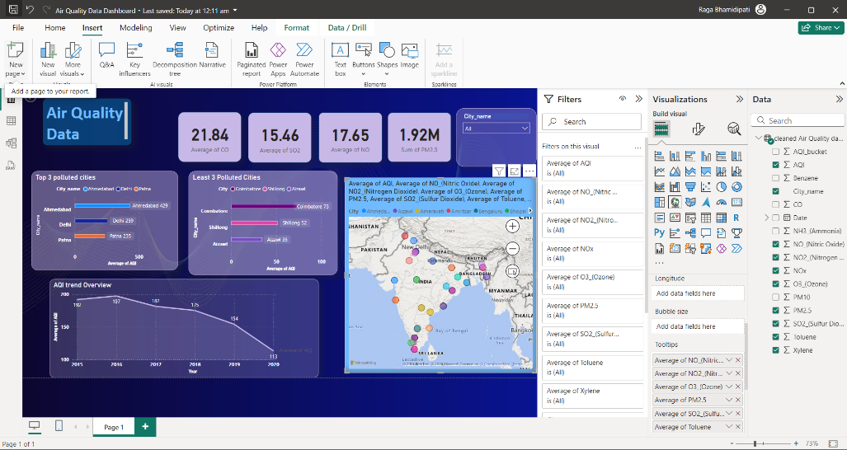

The following visualizations were generated to support the analysis:

1. **Top 3 and Least Polluted Cities**:

Bar charts display the average AQI for the top 3 and least polluted cities.

1. **Temporal Trends**:

A line chart showing the AQI trend from 2015 to 2020 highlights a steady decline in pollution levels.

1. **Geographical Analysis**:

A map visualization plots city-level pollutant averages across India, allowing for regional comparison.

1. **Key Pollutant Averages**:

Indicators for CO, SO2, NO, and PM2.5 summarize their respective national averages for the analyzed period.

*Note: Visualizations were prepared exclusively using Power BI, and the matplotlib library was not utilized.*

*All visualizations are included in the attached Power BI dashboard for further reference*.

**Code Snippets:**

The analysis involved Python for data cleaning and imputation. Below is a summary of the key steps:

1. 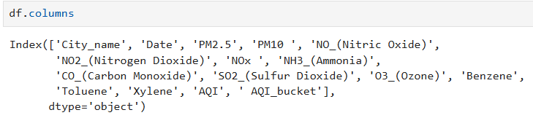**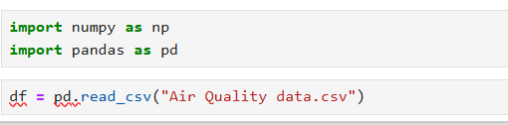Data Cleaning**
2. 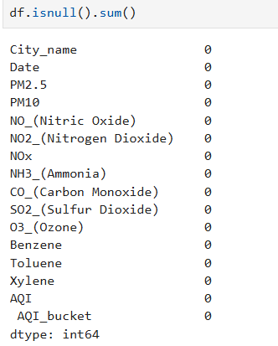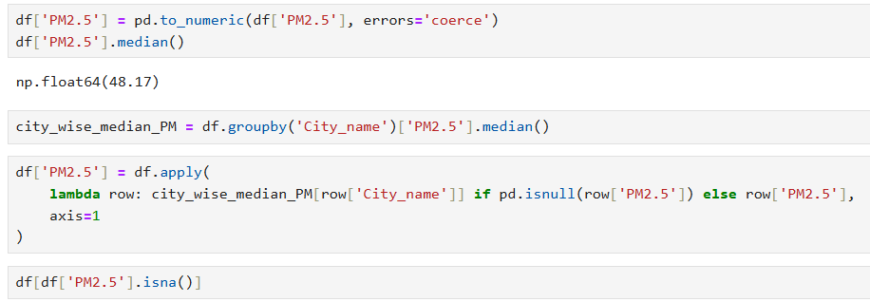**Impute missing values using the city-wise median to every column to remove all the null values.**
3. 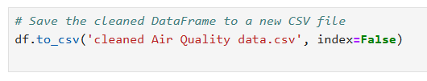**Saved Cleaned Data for further use**

**Conclusion:**

The analysis highlights the urgent need for effective pollution control measures in urban areas. By leveraging the insights from the data and the Power BI dashboard, stakeholders can make informed decisions to improve air quality and public health.

[This document, combined with the attached Power BI dashboard and cleaned CSV file, provides a comprehensive view of the analysis performed and the findings obtained.]